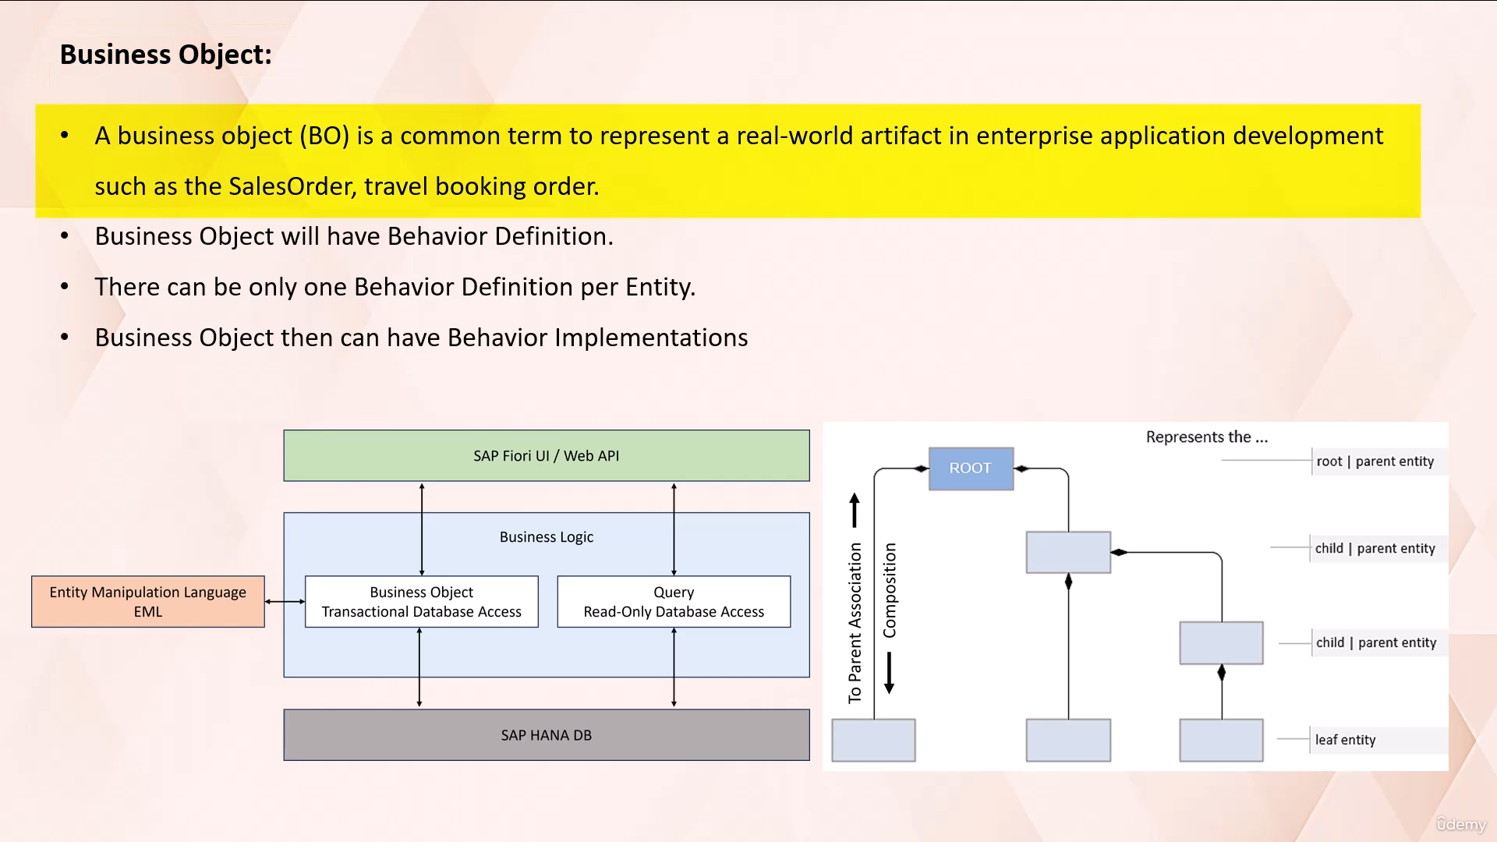

In this video lecture, we are going to discuss an important concept called Business Object.

A business object is a common term to represent a real world artifact in the enterprise application

development, such as sales order, travel booking order, etc..

In Abap.

RESTful application programming model A business object is a central component that enables transactional

access to data described by CDs.

Views.

A business object is not a repository object.

It is made up of several components and their relations.

Business object is a collection of three nodes where each node represents one CDs view.

Now let's dive into structure of business object.

In Abap RESTful application programming model A business object is based on a special tree like hierarchical

structure of CDs entities of a data model.

From the structural point of view, a business object consists of a hierarchical tree of nodes, where

the nodes are linked by a special kind of association, named compositions, and two parent association.

A composition is a specialized association that defines a whole part relationship.

A composite part only exists together with its parent entity.

In another term's, the line item record exists only if header record exists.

Because the top parent entity of CDs, Composition Tree, is the root entity that represents the business

object.

With a large composition tree.

Business objects can be fairly complex or they can be very simple by just consist of one root entity

alone.

Each business object has exactly one root entity.

A root entity is a CDs view defined using addition root.

A root entity can have one or more child entities, but cannot have parent entities.

CDs.

Compositions can be used to define one or more child entities of each CDs entity of a business object.

Before a CDC entity can be defined as a child entity, it must contain a two parent association with

the parent entity.

A parent entity is a serious entity of a business object that uses CDs composition to define child entities.

Each child entity can have exactly one parent entity.

A CDSS entity of a business object that is not a parent entity or in which no child entities are defined

using CDs compositions, is called a leaf entity.

Now let's look at the example here.

You can see in this example multiple CDs entities are linked forming a hierarchical tree like structure

that defines a data model.

In this example, we have three main entities.

Travel entity, booking entity and booking supplement entity.

In CDs.

Entity travel A keyword route is used to define the CDs entity as a route entity.

You can see here a special association named composition is used to define child entity booking.

Insidious entity booking a special association named.

Association to parent is used to link this entity to its parent entity.

Rival and a special association named composition is used to define child entity booking supplement.

So here CDs entity booking is a child to the parent entity travel and it has a child entity name booking

supplement.

In CDs.

Entity booking supplement A special association named Association to Parent is used to link these CDs

entity to its parent entity booking, and it doesn't have any child entity, so it becomes a leaf entity.

Now, I hope with this example you understood the structure of business object.

Now let's discuss about the behavior of business object.

Business object behavior is defined in behavior.

Definition.

A behavior specifies the operations and the fill properties of an individual business object in Abap

RESTful application programming model.

It includes behavior characteristics such as draft ETag feature control, and authorization.

It also includes a set of operations such as create, update, delete and action.

A behavior definition always refers to a CDs data model.

As shown in the figure, a behaviour definition relies directly on the CDs root entity.

One behavior definition refers exactly to one root entity, and once it is, root entity has at most

one behavior definition, which also handles all the included child entities that are included in the

composition tree.

A business object, then can have behavior.

Implementations.

The implementation of behavior definition can be done in single Abap class, or can be split between

arbitrary set of Abap classes.

There are two kinds of business objects managed and unmanaged.

For managed business object.

Its behavior is fully or partially provided by managed business Object Provider.

For an unmanaged business object, its behavior must be fully provided by Abap behavior.

Implementations.

Now let's discuss about the Business Object Runtime in the context of Abap RESTful Application programming

model.

A business object transaction refers to a sequence of operations performed as a single logical unit

of work.

A business object transaction begins when a business object is first accessed, and ends when all the

changes to the business object are either committed to the database or rolled back.

The Business Object runtime is an environment where the business objects are manipulated and their changes

are stored in the transactional buffer until they are persisted in the database.

The Business Object Runtime consists of two main parts interaction phase and save sequence.

Interaction phase is the first part of Business Object Runtime.

During this phase, a consumer can call business object operations to change the data and read the instances

with or without transactional changes.

The business object keeps the changes in the internal transactional buffer.

Silver sequins.

This is the second part of Business Object Runtime.

When all the changes are done, the data must be persisted.

This happens in the save sequence.

Same sequence is called after at least one successful modification was performed during the interaction

phase.

The transactional buffers stores the data during business object transaction.

This includes the instances of business object that are being manipulated.

Entity manipulation language, also known as EML, is used to access the data in the transactional buffer.

Email is a part of Abap language that allows you to control the behavior of business objects.

It provides syntaxes to perform operations such as read, create, update and delete.

In this video lecture we have discussed what is business object?

Structure of business object.

Behavior of business object and business object runtime.

We have also discussed about the transactional buffer and way to manipulate data inside it.

So that's it for now.

See you in next video lecture.